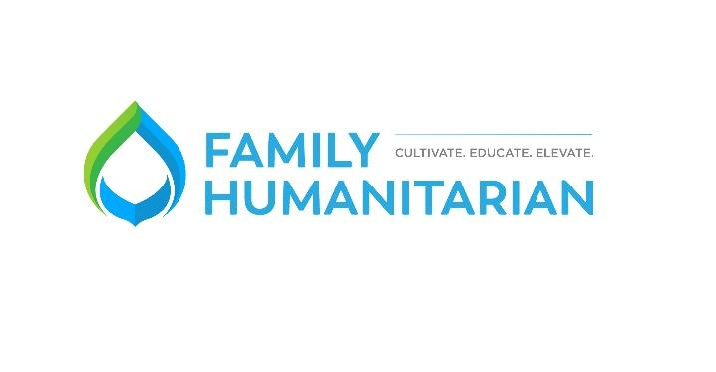
Dear Friend,
Women and children in the developing world walk an average distance of 4 miles per day to collect water and nearly 1 in 10 people worldwide live without clean water. Clean water is essential to stop the spread of disease. Access to clean water means education, income, and health – especially for women and children. Clean water changes everything! Family Humanitarian helps to ease these burdens by providing suitable water sources to these struggling communities.
We are asking for support for our Walk 4 Water campaign. We have a relationship with the Highland Run Club for kids in Highland, UT. The organizer of HRC has created a free run club for kids in the North Utah County community. We want to give these kids the chance to use their miles ran to benefit others.
Our hope is that you would sponsor HRC in whatever capacity you see fit. 100% of any sponsorship provided would be given to Family Humanitarian. Examples could include: dollar for every mile ran through the summer, $100 donation for every 100 miles the children run, a monetary match for milestones during the entirety of the club, or our end of year 5k. By doing so, we would be giving an opportunity to our local youth to serve underprivileged youth across the globe with clean water.
We’d love to acknowledge your efforts on the HRC social media site, as well as have your logo displayed at every run club gathering where most parents attend with their child.
What makes Family Humanitarian Unique?
- Through the design and manufacture of our own drills and the employment of our own drill teams, Family Humanitarian can provide lifetime access to clean water for 75% less cost than most other non-profits.
- 100% of your money brings clean water to people in need. Private donors cover our operating costs so you can give knowing your whole gift will help bring clean water.
- Donors are directly connected to the water projects they made possible through pictures and video.
- Family Humanitarian embraces principles of self-reliance and sustainability, ensuring that projects continue to produce clean water for a lifetime and beyond.
I’ve included for reference, the HRC stats for 2020 as well as Family Humanitarian’s 501c3 determination letter. Thank you for your time and consideration of this request. We appreciate your generosity and your support. Please feel free to reach out to me with any questions you may have.
Sincerely,

Family Humanitarian
www.mywalk4water.com
www.familyhumanitarian.org
EIN# 45-2725284
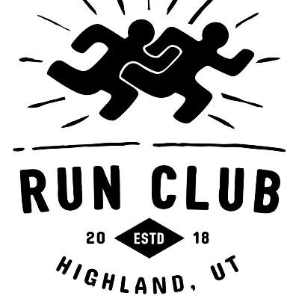
Highland Run Club Stats - 2020

10 weeks
231 runners
8,400 miles
75% runners ran 10 miles
40% of runners ran 40 miles
Top runner ran 200 miles

